XT Core – Assignments

By: Jugal Joshi [141963]

Contents

1. The headings, lists 2

2. Food Recipe 5

3. Float- Lab1 5

4. Float- Lab2 6

5. Position relative lab 7

6. Create similar layout to Agoda 8

7. Position absolute 9

8. Position absolute lab 10

9. Sapient Tours Website design 11

10. Z-index example 12

11. Max width example 12

# The headings, lists

**Problem Statement**: Hands on for the Heading elements and Lists in HTML

**Code Files:** index_headings.html, index_list.html

**Output**:

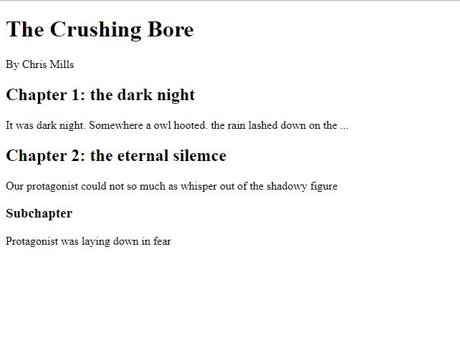

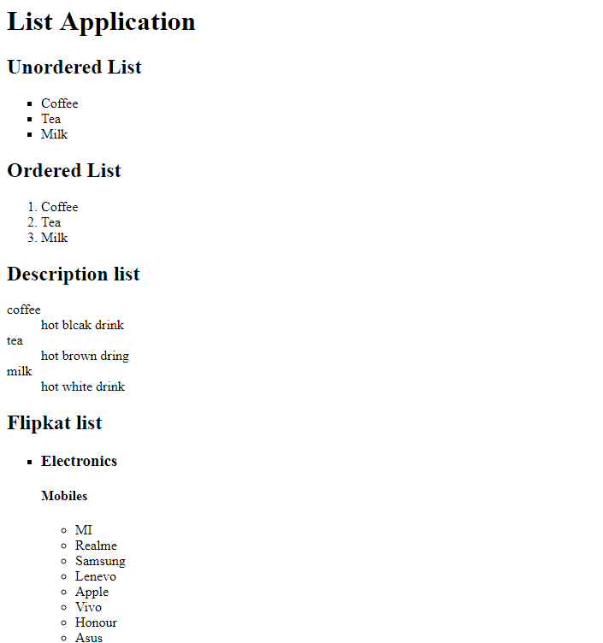

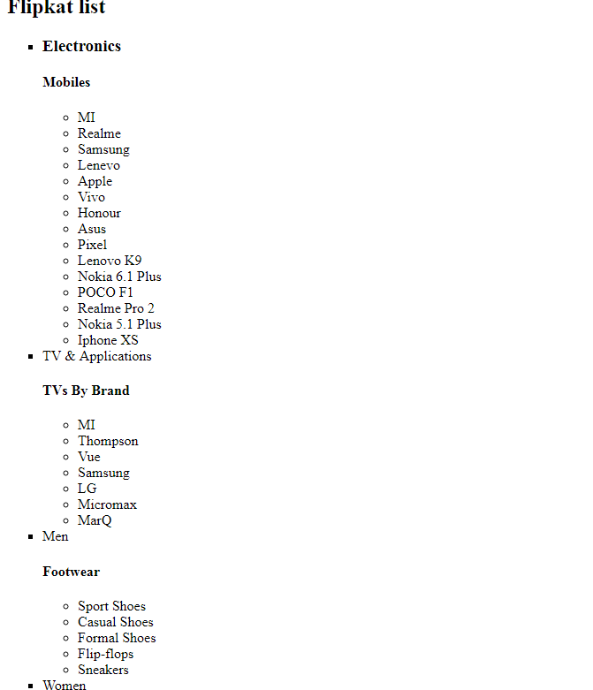

# Food Recipe

**Problem Statement**: create a recipe web page with fixed width of container/wrapper and auto margins for left and right.

**Code Files:** index_boxlayout.html

**Output**:

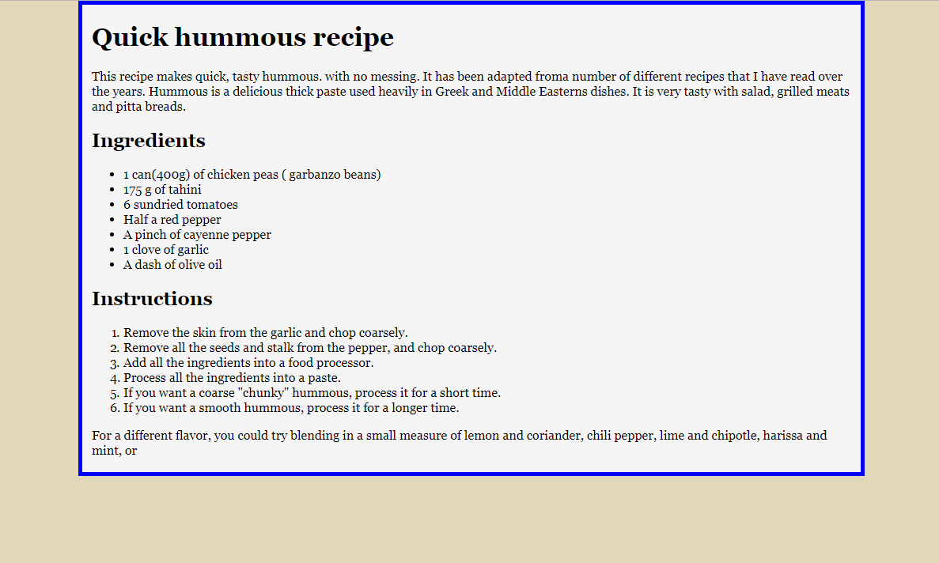

# Float- Lab1

**Problem Statement**: create a column layout with Header, footer and 3 columns which have a right margin of 2px between them. We need to make sure we ‘clear’ the Floats so that Footer is aligned at correct place. Columns should have some different color.

**Code Files:** index_float_lab.html

**Output**:

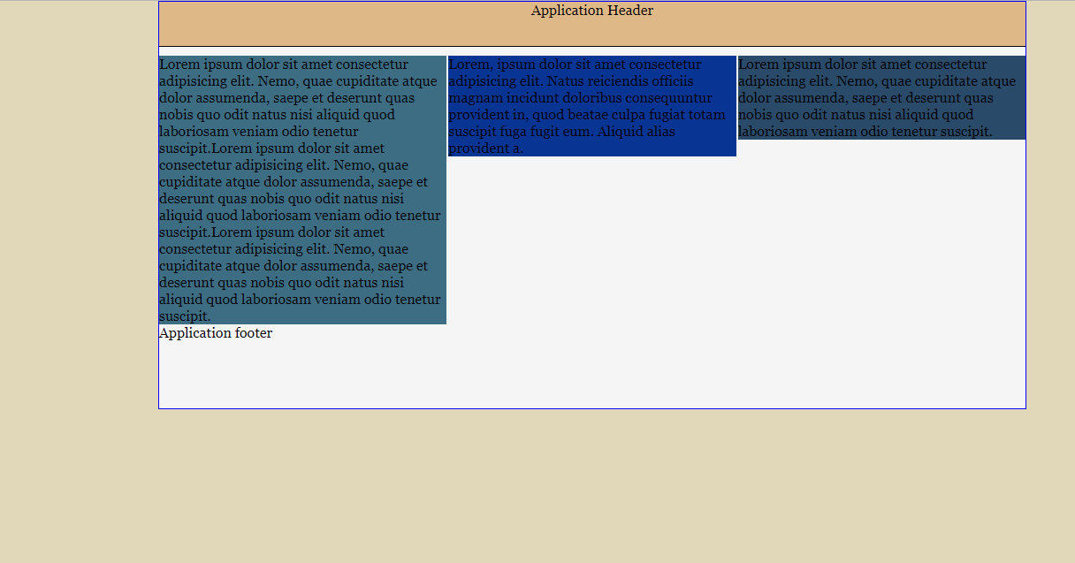

# Float- Lab2

**Problem Statement**: Apply the Clearfix, when the Float element inside a container is ‘taller’ than the element succeeding it and we have some text following the Container.

**Code Files:** index_float_fixes.html

**Output**:

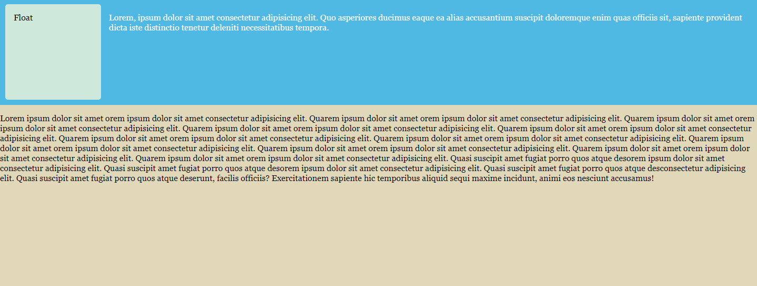

# Position relative lab

**Problem Statement**: use position relative to position boxes

**Code Files:** position_relative_lab.html

**Output**:

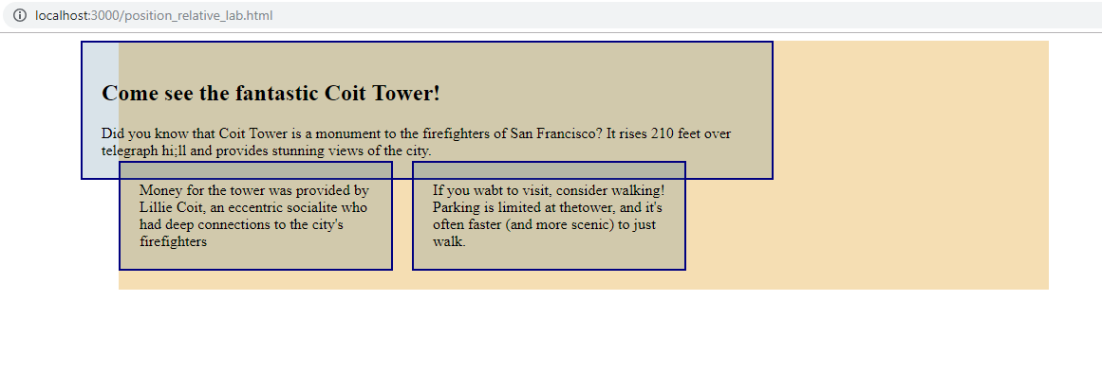

# Create similar layout to Agoda

**Problem Statement**: Create similar layout to Agoda

**Code Files:** Agoda/agoda.html

**Output**:

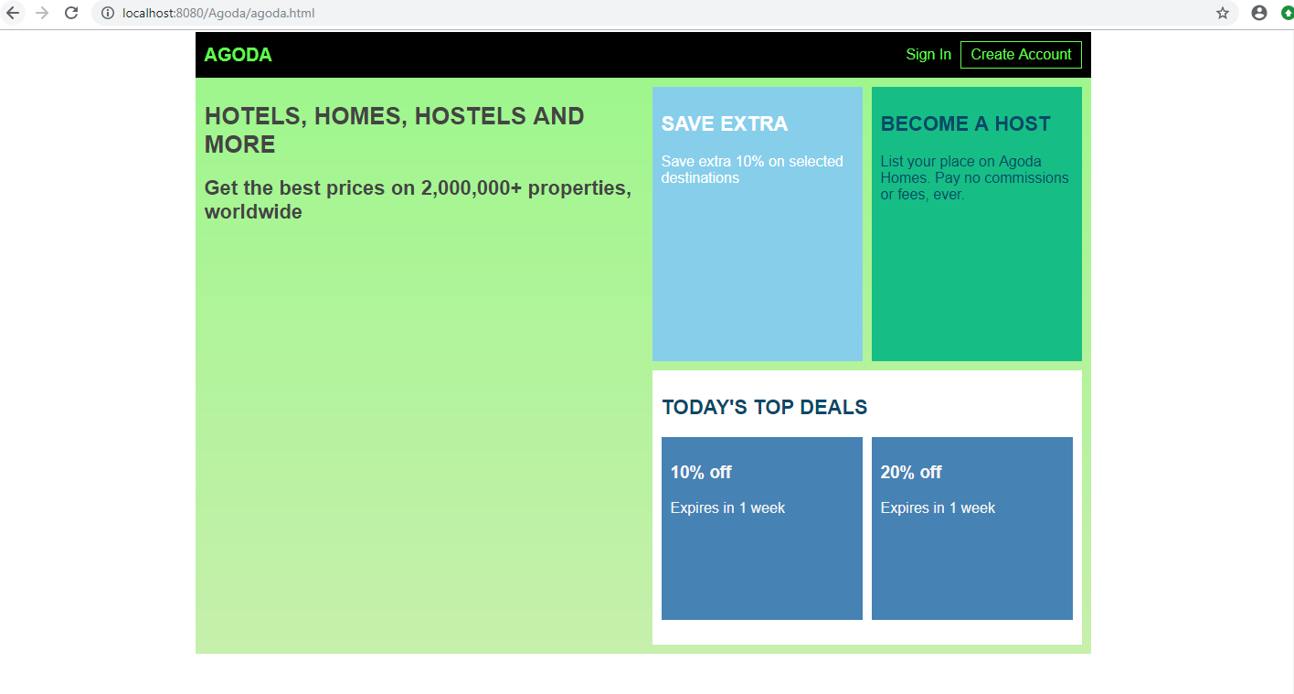

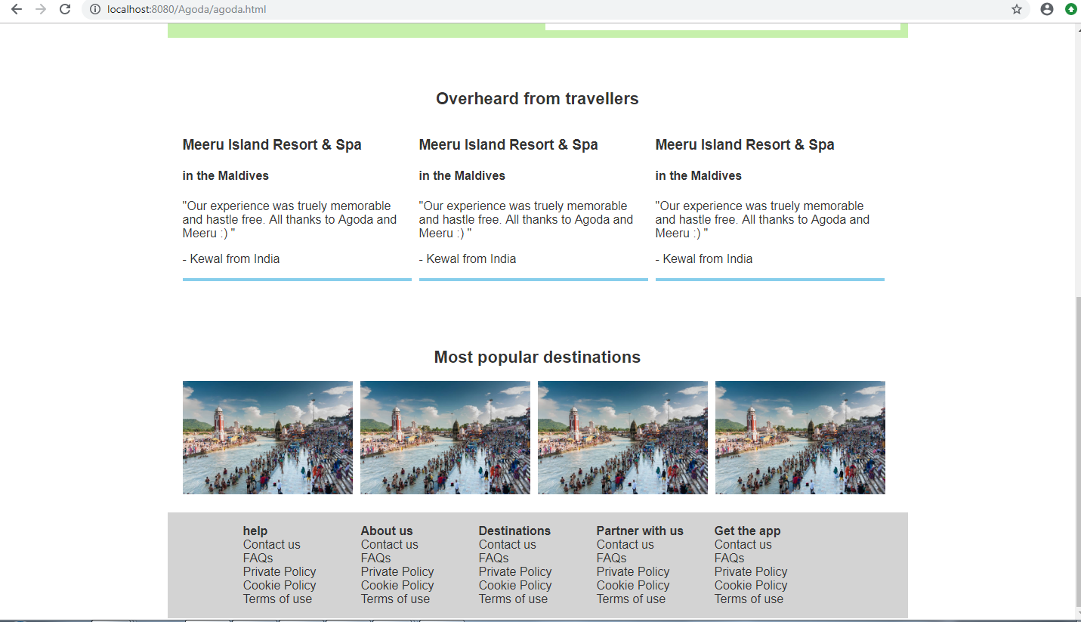

# Position absolute

**Problem Statement**: Create 4 boxes connected in the corner of position relative parent.

**Code Files:** position_absolute.html

**Output**:

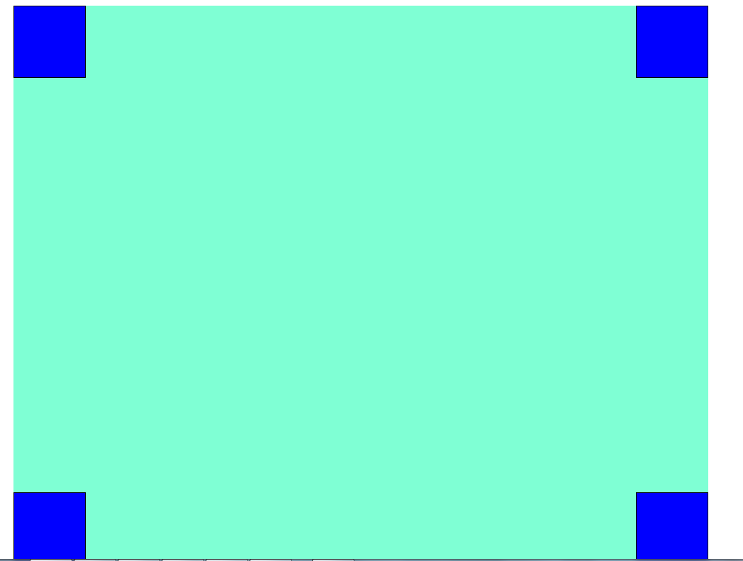

# Position absolute lab

**Problem Statement**: create boxes and arrange like chess board rectangles using position absolute and relative.

**Code Files:** position_absolute_lab.html

**Output**:

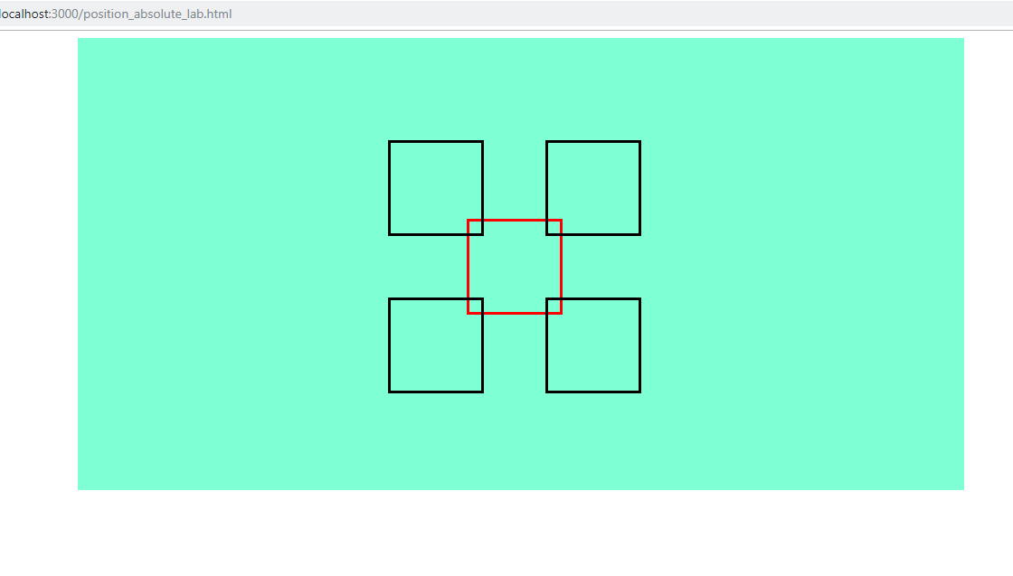

# Sapient Tours Website design

**Problem Statement**: Create Sapient tours website design with content provided

**Code Files:** SapientTours/index.html

**Output**:

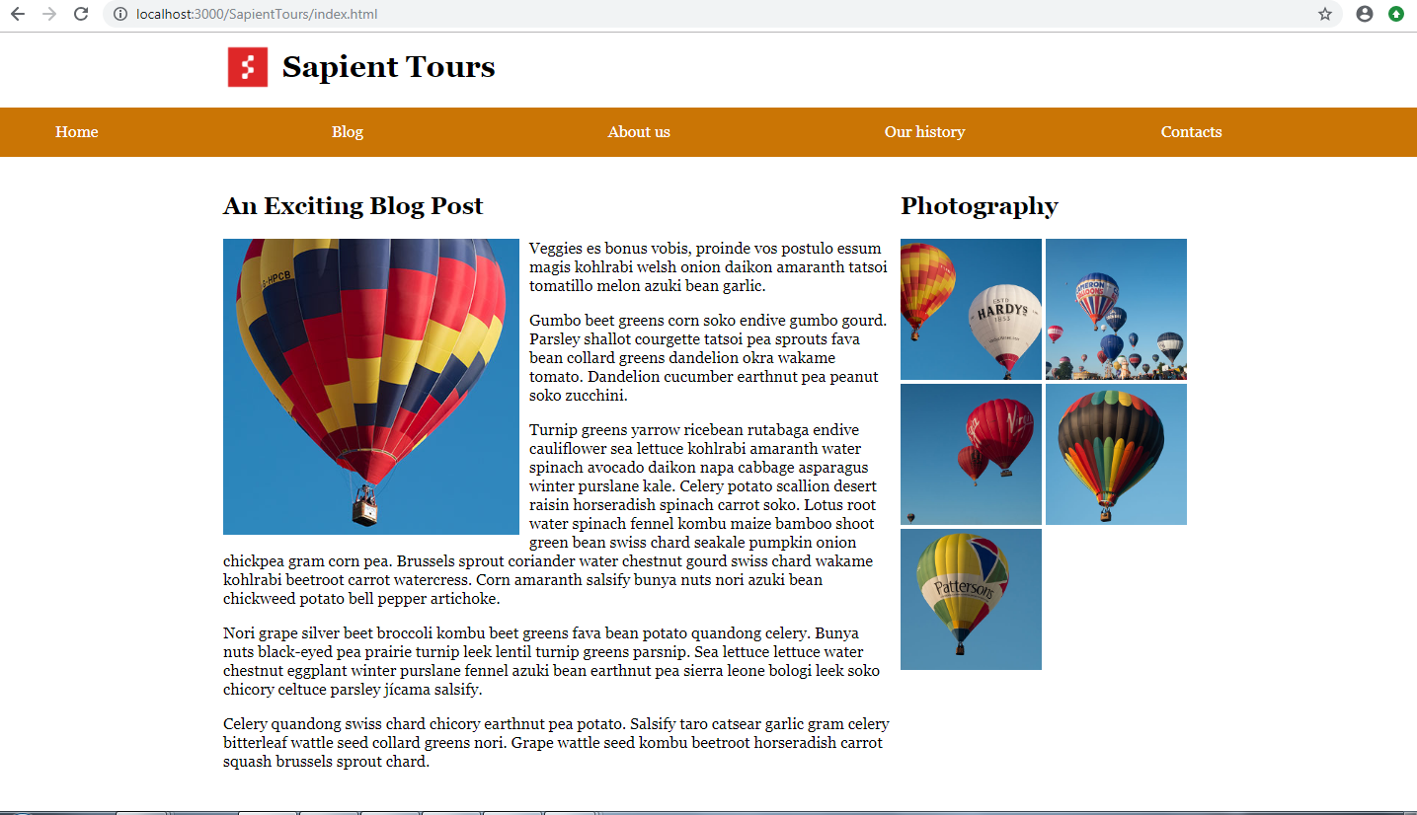

# Z-index example

**Problem Statement**: Create overlapping paragraphs using z-index

**Code Files:** z_index.html

**Output**: 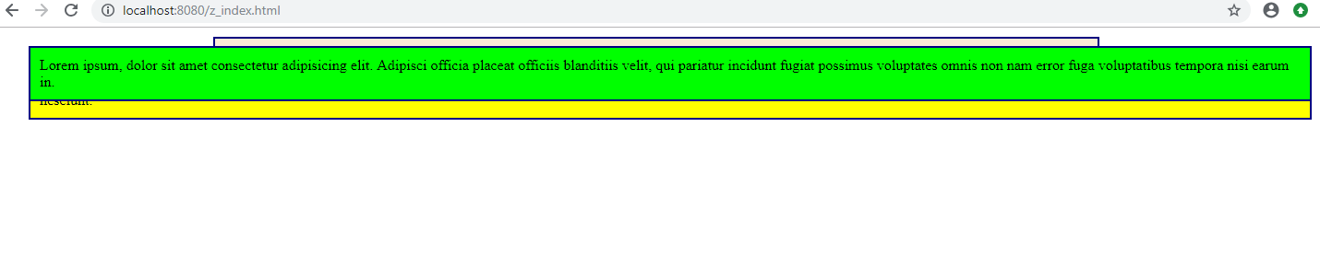

# Max width example

**Problem Statement**: Create paragraphs using max width

**Code Files:** max_width.html

**Output**: 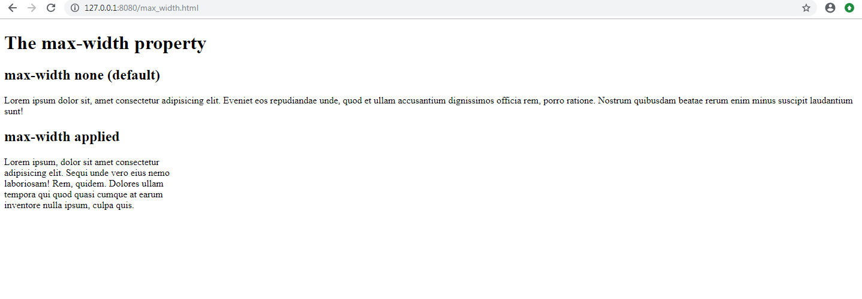

# Overflow example

**Problem Statement**: Show different overflow examples.

**Code Files:** overflow.html

**Output**: 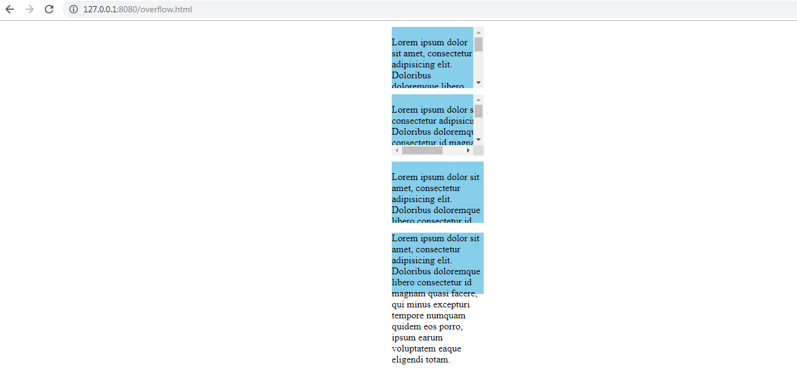

# 13. Background example

**Problem Statement**: Apply different backgrounds to element.

**Code Files:** background.html

**Output**: 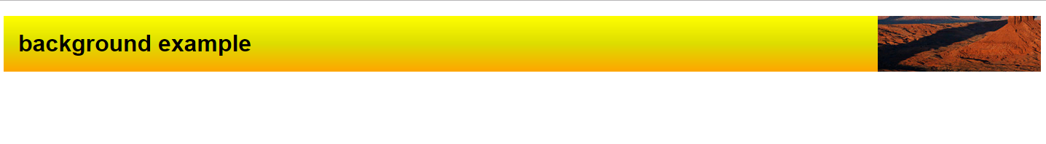

# 14. Border radius and box shadow example

**Problem Statement**: Apply border radius and box shadow.

**Code Files:** border_radius.html

**Output**:

